PARISH NEWS
The Deverills & Crockerton
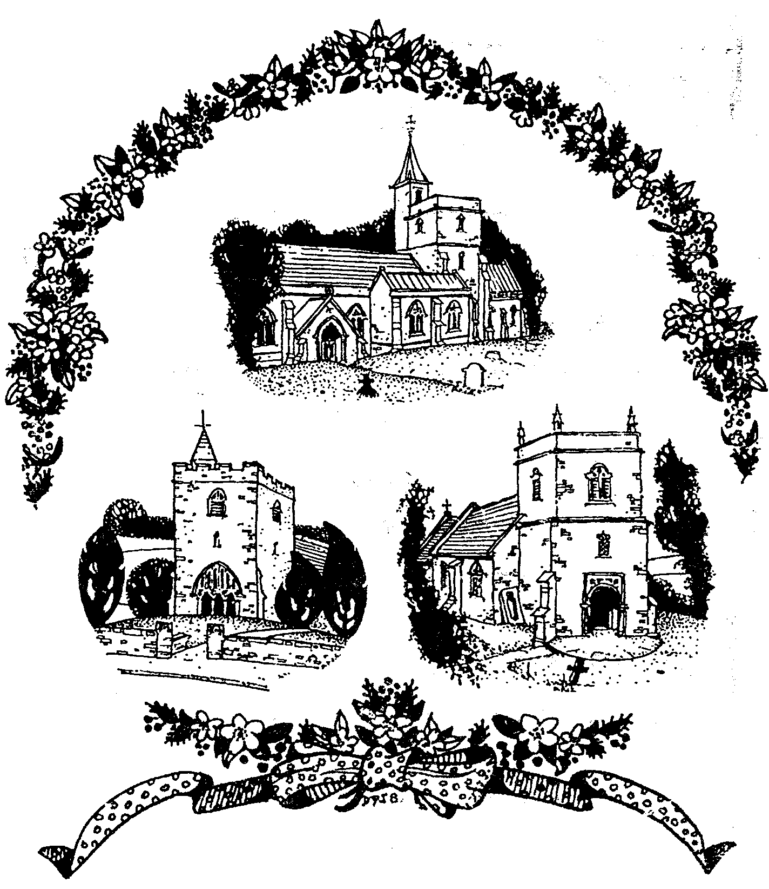

Our Three Churches
By
Dennis Smith
December 2009

Look inside for local information

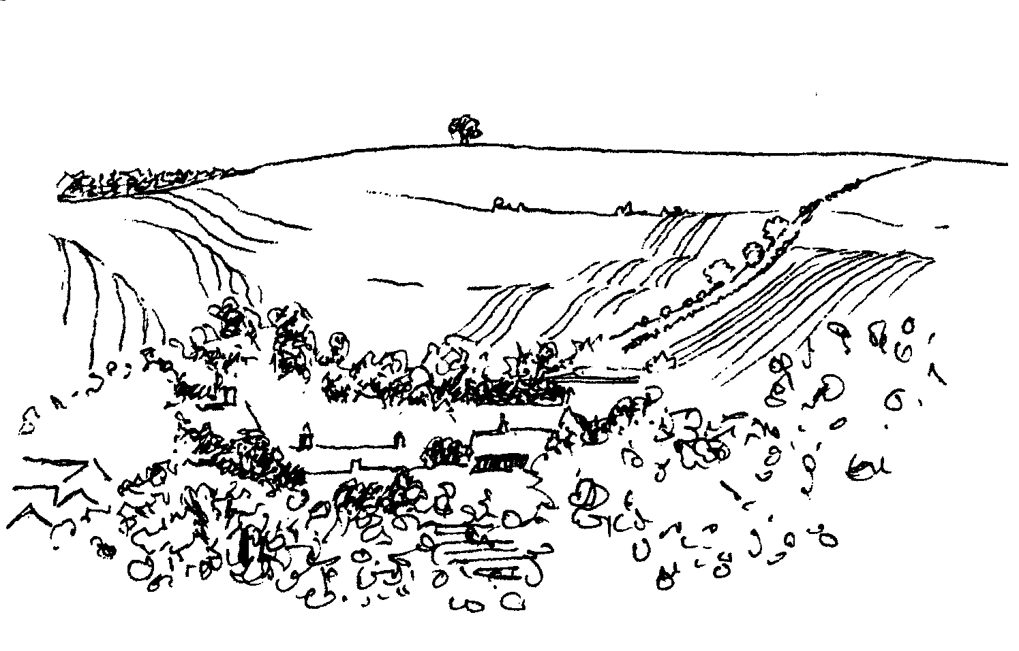
-2-

Longbridge Deverill Village Hall Committee invite you to
A Musical Christmas ‘Get Together’
Saturday 12th December at 5.00 pm
Carol singing, festive readings and much more
Mulled wine and seasonal refreshments served
Everyone welcome
No tickets required, a small donation appreciated

Upper Deverills Village Hall
Christmas Bingo - Friday 4th December 7.00pm
Players of all ages are invited
Lots of prizes and seasonal snacks
Come and join in this fun filled evening!
All profits towards the new kitchen
Bring your own drinks

Macmillan Cancer Support
Winter Warmer - Feast of Entertainment
Saturday 5th December at 6.30 pm
St. John's Church
Boreham Road, Warminster
£3.00 on the Door

Coffee, Cards and Chat
Come and enjoy looking at the new range of cards,
ribbons, wrapping paper, and other exciting items
displayed by John and Maddie Goodden
in the Upper Deverills Village Hall on Thursday 19th February
between 10.30 and 12.00 noon - everyone is welcome
Donations will be made to the hall and the church

CROCKERTON VILLAGE COMMITTEE and CROCKERTON SCHOOL
Tuesday 15th December
Come and join the Children’s Carol Service Procession
Start Broadmead Lane 6.00 pm,
progressing to The Bath Arms, Crockerton for a grand switch on of Christmas Tree lights and blessing of the tree by
Rev Norma Payne, our Team Vicar
Carols, mulled wine and mince pies; please bring a Christmas decoration or bird food to put on the tree
All are welcome

-3-

The Rector writes:
There is little doubt what most of us will be doing in the next four weeks. The Christmas rush to get everything organised will dominate our lives ~ cards to be written, gifts bought and sent, the preparation of food, plans about who will visit who and when. The rush is on!
Yet in just a few weeks, Christmas will be over, and we will be welcoming a New Year, making new resolutions and probably planning our holidays! Come Epiphany and Twelfth Night, we will be taking the decorations down and putting them away for another year. Things will be back as they were – or will they? Will life be the same? Will we be changed by the birth we celebrate? If we take Advent seriously, we shall have the chance to think again about what it means to say that God comes into the world in the humility of birth at Bethlehem. He still comes into the world in all its mess and pain and joy, longing for us to recognise him. Our Advent preparation for the festival of Christmas enables us to put away the things of darkness and to put on the armour of light. Now is the time to meet God, in our prayers of preparation. Perhaps we should ask ‘how many praying days till Christmas?’ and not shopping days!
In and through our prayers, Advent is a time to make space, to work at understanding God’s love for us. The world says ‘Hurry! Get on with things’. The Advent invitation gives a different message. ‘Wait, be still, alert and expectant.’
Follow the leading of the Christmas star as you journey through Advent. Burn an Advent Candle to help in the marking of these ‘praying days’, or treat yourselves to an Advent calendar. Be ready to celebrate God becoming involved in our world in Jesus, and his invitation to us to make time for him. May the praying days of Advent help us remember God who comes to us every day, and longs for us to respond with our love and service.
And when it comes, may the peace and blessing of Christmas be yours!
Norma Payne
News from Dr Francesca Elloway CMS in the Congo
For two weeks in November Francesca was in Kenya at a Mission Hospital, a hundred miles from Nairobi. She went to improve her ultrasound scanning technique with the help of the radiographers there. She wanted more training to make good use of the mobile ultrasound scanner obtained for her medical centre in Aru. She took the opportunity to go on ward rounds in the hospital with the doctors there to exchange ideas, as she is very isolated in Aru. Francesca is enjoying her correspondence course in palliative medicine, though she finds it hard to multitask as a mature student! Baba, Francesca’s administrator, will be taking his final examinations for a management degree and will then return to Aru. Please pray for him as the exams will be in English which will be particularly hard for him. The Diocese in Aru has had its third Synod meeting; the theme was ‘To love one another is to be best transformed’. Francesca sends greetings to all in the Deverills. A full copy of her letter can be obtained from Elisabeth Atkinson.

-4-
Poppy Appeal 2009
The Royal British Legion is very grateful to all who collected and contributed to the appeal and I thank the fourteen dedicated house to house callers who gave so much of their time making the collections, and the people who look after the four static collection boxes. Again this year, the collection in the Deverills and Crockerton was the highest to date, exceeding last year’s record by £201.66. Thank you again to all those who gave so generously and huge thanks to the collectors, also my able assistant counter of cash, who was given the heaviest collecting boxes! The breakdown by villages was: Kingston £207.98, Monkton £142.96, Brixton £117.78, Hill £116.68, Longbridge £248.53 and Crockerton £354.09. The church collection on Remembrance Sunday was £320.00 and the four tins at static points totalled £395.74. An overall sum of £1,903.76. A wonderful achievement, thank you.
Robin Greenwood - Hon Organiser
Stars Appeal Tidworth 3K Fun Run
A big thank you to everyone who sponsored me for this appeal. Thanks to you, I was able to raise £258 towards the ‘Caring 4 Kids’ campaign, providing a ‘state of the art’ children's unit, that will open in 2010 at Salisbury District Hospital. The ‘fun walk’ turned out to be more challenging than expected. The rain came down in buckets, making the ground very difficult for fellow Governor Sara and me helping to push Andrew in his wheel chair. At times the wind was behind us but most often in front. We made it to the finishing line just in front of the of the wheel barrow team!
Carole Noonan Governor for West Wiltshire, Salisbury NHS Foundation Trust
Charity Event
Thank you to everyone who attended and helped on this occasion. A wonderful £230 was raised for Kampala Music School and the Secondary School at Juba, Sudan.
A Parish Calendar for 2011
There are so many beautiful views in the Deverills and around Crockerton and Horningsham, with many interesting ‘corners’ in the villages, so there should be no difficulty in compiling a parish calendar. All that is required is for a few people to go out with cameras and record the changing seasons. A Committee of Taste would then be convened calling for pictures to be sent in during September. There would be time to choose the best scenes and get the calendar printed in time for it to be sent as gifts for Christmas! Profits to go to a ‘good cause’. To inspire our photographers a £10 prize may be awarded for the picture chosen to go on the front of the calendar. We should start snapping now. Please contact me if you are interested in getting involved.
Nigel Hawkins 840920
Pre-School Children and Parent Thursday Group
The group will be closed for the Christmas holiday on Thursday 17th December and will reopen at 10.00 am on Thursday 14th January, when we hope to welcome our regular and new families at Longbridge Deverill Village Hall. For further details contact Barbara Beilby 844995.

-5-

30 mph Stickers for Wheelie Bins in the Upper Deverills
Speeding in the valley has consistently been top of the list of matters of concern to parishioners. On your travels around the county recently you may have seen 30 mph stickers on wheelie bins put out on collection days. These stickers are a very visible and effective reminder of the speed limit. Trials have been taking place which have met with considerable success, and Wiltshire Council has given the Rural Police Department a grant of £350 towards the cost of the stickers. As a result of some savings in this year’s budget, the Upper Deverills Parish Council will fund an initial purchase of 80 stickers. Residents in houses on the B3095 in Brixton, Monkton and Kingston Deverill, Hindon Road in Monkton Deverill and Maiden Bradley Road in Kingston Deverill will be offered stickers for both grey and green bins so there would be a weekly reminder to drivers of the speed limit. If you would like to participate in the scheme please contact your councillor, Monkton Deverill - Felicity Wheeler (844683), Brixton Deverill - Robin Greenwood (840743), Kingston Deverill - Sarah Fagan (844123). The date of our next meeting will be Wednesday 6th January at 7.30 pm when we look forward to seeing any parishioner who would like to attend.
Lady Felicity Wheeler - Chair Upper Deverills Parish Council
Longbridge Deverill & Crockerton Parish Council
As we are approaching the anniversary of the flood in the Deverills last year, please could we remind all landowners with land adjoining the river to ensure that their section of the river is clear and free-flowing. Some work has been undertaken in Longbridge Deverill and Crockerton and the Parish Councils are in contact with all agencies involved to try and ensure that a similar problem does not occur this year.
On behalf of all the Councillors, may I wish everyone a ‘Very Happy and Peaceful Christmas’, and we look forward to seeing anyone who would like to attend our next meeting on Monday 4th January at 7.30 pm.
Volunteer Flu Friend
Have you organised your Flu Friend? A flu friend is a person who is trusted to collect antiviral (medicine) for someone diagnosed with swine flu. This may be a friend, relative, colleague or neighbour. Importantly though, not everyone has access to a flu friend, therefore the role of volunteer flu friend is really important. Each person requiring antiviral medication is given a unique reference number. The role of a Volunteer Flu Friend is to take this unique ID number along to a named pharmacy, and deliver the antiviral provided by the pharmacy to the patient's home address. We do not have many volunteers registered in this area, if you would like to become a volunteer flu friend and help people in your local area please contact the PCT Swine Flu Incident Room on 01380 7333701 or email swine.flu@wiltshire.nhs.uk with your name, telephone number and home address.
Carole Noonan Community Emergency Volunteer 844606

-6-

Deverill Valley & Crockerton Women's Institute
There will be no regular WI meeting until Monday 11th January. Skittles and Scrabble will be played in the evenings meanwhile, ring 212415 or 840209 to join us. The recent Annual Meeting of all Wiltshire members was voted the most relaxed and enjoyable ever! There was news of exciting changes to take the whole WI movement toward its centenary, and also entertaining and topical items. These included a presentation on the origin and current role of the Air Ambulance, a presentation explaining how TV is ‘going digital’ in this area and a fashion parade of the decades celebrated 90 years. In the latter some trustees modelled clothes of the times ending with our retiring County Chairman in the dress, hat (and umbrella) she wore when she represented members at a Royal Garden Party on a wet day this summer. The high spot of the meeting was charismatic Sheila Dibnah’s hilarious but fond description of life with her late husband Fred, the steeplejack. Your local WI are planning activities now for the coming year, we would love to share them with anyone as a visitor or (ladies only!) a new member.
Jill Russell
The Cast on Club
Thank you to those who have come to the previous meetings. This month we will meet only on Thursday 3rd December from 10.30 am - 12.30 pm at Judy Munro’s house, Whitepits Lodge, Kingston Deverill. Everyone is welcome whatever your knitting skills! The patterns are simple. Please bring some soft baby wool and a pair of 8 or 9 needles, if you have them. Contact Judy 844385 for directions.
Tennis Coaching
A group of ‘girls’ meet at the Warminster courts at 9.30 am on Tuesdays for coaching. If you are interested in joining us please contact Judith Hirons 845255.

Salisbury Theatre Club Trips
Monday 15th February
Private Lives by Noel Coward
Monday 15th March
The Glass Menagerie by Tennessee Williams
Monday 19th April
Low pay? Don’t pay! by Dario Fo
Monday 17th May
Les Liaisons Dangereuses by Christopher Hampton
The cost is £17.00: theatre seat £12.00 and coach trip £5.00
Please book early to ensure tickets, payment in advance to Mary Stewart Cox
Tel 840877 at Longmead, Brixton Deverill, Warminster BA12 7EJ
Coach leaves Kingston Church 6.10 pm and collects through the Deverills
Performances begin at 7.30 pm

-7-
Santa Fun Run at Longleat for Southern Spinal Injuries Trust
Sunday 6th December at 10.30 am
This will be a great family event to kick off the festive season! Every entrant will receive a Santa suit in which to run, jog or walk 2 miles around Longleat and there is a commemorative medal for all those who cross the finishing line. Entrance is £6.00 per child and £12.00 per adult. For more information and to download an entry form, please visit www.ssit.org.uk or call Sophie Lawson on 841261.
Upper Deverills Village Hall
Christmas Bingo Friday 4th December 7.00pm
We are hoping to attract players of all ages including children with adults and so have set the ‘eyes down’ time earlier at 7.00 pm. This is a fun evening and we shall have seasonal snacks, as well as prizes to suit all ages and tastes. Please support this activity and help raise funds for the new kitchen.
Carol Service Sunday 20th December Kingston Deverill Church 6.00 pm
Last year the Carol Service was very well supported and we had many standing at the rear. The Hall Committee plans are no less ambitious this year when our traditional concert will have some new aspects especially for the children, as well as seasonal snacks and mulled wine afterwards. The Upper Deverills Village Hall would like to thank all our helpers and supporters and wish everyone a very merry Christmas and happy new year.
Richard Cousens - Chairman
Longbridge Deverill Village Hall
Christmas Evening on Saturday 12th December
Please come and join us for an evening of carol singing and much more. Mulled wine and refreshments to be served during the interval, see page 2.

Burns Night on Saturday 23rd January
More details in the next Parish News.
Heatstroke to Frostbite
Saturday 6th February in Longbridge Deverill Village Hall
The doors will open at 6.45 pm for a glass of wine and the talk will be at 7.00 pm followed by supper. Information and tickets (£12) from Nigel and Marie Poole 840902 or David and Peggy Prior 216904. Reserve this evening for a fascinating talk by Chris Todd about his experiences in the Gobi Challenge of July 2008 and the ultimate challenge ‘6633’ in March 2009. The Gobi Challenge was to complete 150 miles in 6 days, almost a marathon a day in temperatures of +40C. The 6633, named because it starts on the Arctic Circle at 66 degrees 33 minutes north, was 350 miles in 7½ days with temperatures down to -40C. From a large international start list, Chris was the only person to finish this race. Chris completed these challenges to raise money for the Wiltshire Blind Association. The talk and supper will help raise money to support an adventure weekend in Scotland for a group of the Wiltshire blind so that they can experience the thrills of canoeing, abseiling, climbing and fell walking.

-8-
SERVICES PARISH OF DEVERILLS & HORNINGSHAM
Sunday Advent 2
6th December Kingston 8.00 am Holy Communion 1662
Longbridge 10.30 am Morning Worship
Horningsham 10.00 - 12.00 Advent Workshop Village Hall
Horningsham 4.00 pm Advent Service
Sunday Advent 3
13th December Kingston 10.30 am Holy Communion
Horningsham 11.15 am Holy Communion
Sunday Advent 4
20th December Brixton 10.30 am Holy Communion
Kingston 6.00 pm Village Carol Service
Thursday Christmas Eve
24th December Horningsham 3.00 pm Carol and Crib Service
Longbridge 5.00 pm Crib Service
Friday Christmas Day
25th December Kingston 9.30 am Holy Communion
Horningsham 10.00 am Holy Communion
Longbridge 11.15 am Christmas Day Service
Sunday St John the Apostle
27th December Brixton 10.30 am Holy Communion
Sunday Epiphany
3rd January Brixton 8.00 am Holy Communion 1662
Longbridge 10.30 am Epiphany Service
Horningsham 4.00 pm Holy Communion

Tuesday, Wednesday, Thursday, Friday Longbridge 8.30 am Prayers
Wednesday Longbridge 10.15 am Holy Communion

Parish Prayer Group meeting - Deverills and Horningsham
Tuesday 1st December from 7.00 pm to 8.00 pm Mary Royall’s house (840338)

Ivy House St Denys Retreat Centre Booking & information (214824)
Saturday 12th December - House Quiet Day

Contact the Clergy
Please contact Norma Payne (841321) or Di Britten (01373 832515) if anyone is housebound and would like communion or a visit at home;
or if someone is ill and needs our prayers; or to discuss any church matter.
Office administrator phone 210149 or email: office@cleyhill-team.org.uk

-9-

SERVICES PARISH OF CORSLEY & CHAPMANSLADE
Sunday Advent 2
6th December Corsley 9.00 am Holy Communion
Sunday Advent 3
13th December Chapmanslade 9.00 am Holy Communion
Temple 11.00 am Morning Prayer
Sunday Advent 4
20th December Chapmanslade 9.00 am Holy Communion
Corsley 6.00 pm Carol Service
Thursday Christmas Eve
24th December Chapmanslade 3.00 pm Crib Service
Corsley 5.00 pm Crib Service
Corsley 11.30 pm Holy Communion
Friday Christmas Day
25th December Temple 9.00 am Holy Communion
Chapmanslade 10.30 am Holy Communion
Sunday St John the Apostle
27th December Corsley 10.30 am Holy Communion
Sunday Epiphany
3rd January Corsley 9.00 am Holy Communion
Christmas cards for Sudan
These handmade cards will be on sale in our churches and at Thursday Group.

Church Cleaners for December
Kingston - Mrs Martyn & Mrs Shuler
Brixton - Mrs Hammick & Mrs Abraham
Longbridge - Monday 7th December 9.30 - 10.30 am - all helpers
Church Flower Arrangers for December
 | Kingston | Brixton | Longbridge
6th Dec | Advent | No | Flowers
13th Dec | “ | “ | “
20th Dec | “ | “ | “
27th Dec | Mrs Stratton | Mrs Hammick | Mrs Atkinson

The Deverills & Horningsham Register
Funeral at Longbridge, followed by cremation
Elizabeth Mary Butler on Wednesday 11th November
Funeral and Burial at Horningsham
Patrick Robin Dye on Thursday 19th November
-10-

Recipe of the Month
Sponsored by Maiden Bradley Community Shop (844206)
Warm Chocolate Surprise
Ingredients
4½ oz dark chocolate (85% cocoa)
4½ oz butter
2 medium eggs and 2 more yolks
4 tbsp caster sugar
4 tbsp plain flour
4 squares of white chocolate (Terry’s orange just as nice)
Method
Grease and flour 4 ramekin dishes
Pre-heat oven to 230C/450F
Break up dark chocolate, add butter, and melt in a bowl over hot water. Set aside.
Whisk the eggs plus extra yolks and sugar until pale, thick and creamy.
Stir in the chocolate mixture then the flour until all are combined.
Put equal amounts of the mixture in each ramekin and push a piece of the white chocolate into the centre of each.
Place on a baking tray and cook for 7-10 minutes
(top should be risen and set but the centre still soft)
Allow the stand for 1 minute, then turn out on a serving plate. Enjoy with cream.
This pudding can be made and chilled in the fridge up to 12 hours before cooking.
Why not order your Christmas Fare from Maiden Bradley Community Shop. We support local producers of poultry, meat, cheeses and vegetables, and have a good selection of cards and gifts. Come and see for yourself.
On Saturday 30th January, in aid of the shop, there will be a presentation of readings in Bradley House about Maiden Bradley from Elizabeth Dineley’s book. She spent her early years at Rodmead Farm; more information next month.

MAIDEN BRADLEY PANTOMIME
Robin Hood of Bradley Wood
Thursday 14th, Friday 15th and Saturday 16th January
Maiden Bradley Village Hall
Doors open 7.00 pm - curtain up 7.30 pm
Tickets £6.00 (£4.00 concession) from Maiden Bradley Shop
Come along and enjoy an evening of music, fun and laughter
For further information please call 844745

Wanted
A local farming family need a house to rent in the area. We have three working sheepdogs (who live outside in their own kennel). If you can help please call us on 01747 820796 or 07522 377663, thank you.

-11-

Where have you been?
The Grange, Whatley, Frome (01373 836522)
What makes a place special is often very hard to define. We have come to see good food as a given and efficient, even charming, service as expected. In a competitive market restaurants have to offer something different to attract customers and even more so if they are new and an unknown quantity. So what is special about The Grange? Firstly, this newly opened restaurant is attached to a well-established cookery school which attracts an international clientele, so the food, as you would expect, is excellent in quality and variety. Secondly, the kitchens form part of the restaurant, so diners can see what is going on. Thirdly, it is in a beautiful setting and has been wonderfully decorated, large windows with marble and wood used extensively, giving it a lovely open airy feel. Finally, the food is priced competitively, with the option of having just a pizza if you do not want a full meal. The owners are keen to attract locals, as well as those from further afield, so there is a bar at the far end of the restaurant where you can just have a drink if you do not want to eat. The whole feel of the place is ‘classy’ but also somehow informal. The setting, high on a ridge with a huge patio and terraced gardens below, and the marble floors and sculptures give the feeling of being in one of the better hillside restaurants in Tuscany. Give it a try! Opening times are: Wednesday to Saturday 12.00 noon until 3.00 pm and 6.00 pm until 11.00 pm; Sunday 12.00 noon until 3.00 pm.
Mes Amis, Beckington (01373 830723)
On our many journeys to and from Bath, Robert and I have taken to calling in at this delicatessen-come-café in Beckington. The food here is excellent and very reasonably priced (£3.90 for a large bowl of soup with bread). The café seats about 20 and is always full, testament in itself to the quality of the food. What is on offer is mainly soup or salad, plus a hot dish of the day such as risotto or lasagne but if that sounds a bit mundane, believe me it is not! The soups are inventive – pea and pesto, or chick pea with lemon, ginger and coriander. Also the salads – roasted pepper with goats’ cheese, plus home made tartlets. You cannot book but whenever we have called in we have had only the shortest of waits for a table, and the delicatessen is so well stocked with a huge variety of interesting and unusual items on offer you can always do a bit of Christmas shopping while you wait. If you would rather eat at home, then all their meals are available as takeaways. This is a super little place which is already doing a roaring trade and justifiably so. It is easy to find, if you enter Beckington from the Warminster side of the A36, at The Woolpack turn right and it is on your right almost opposite the garage. There is usually ample on-street parking. This is a little gem, mes amis!
If you have somewhere you would like to recommend, please send your comments and suggestions to me by email at farthings.kd@btinternet.com or through my letter box at Farthings, Kingston Deverill.
Trish Shuler

-12-

Warminster Rural Neighbourhood Policing Team

Postal Scam: A card is posted through your door from a company called PDS (Parcel Delivery Service) suggesting that they were unable to deliver a parcel and that you need to contact them on 0906 6611911 (a Premium rate number). DO NOT call this number, as this is a mail scam originating from Belize. If you call the number and you start to hear a recorded message you will already have been billed £15 for the phone call. If you do receive a card with these details, then please contact Royal Mail Fraud on 0207 239 6655 or ICSTIS (the Premium rate service regulator) at www.icstis.org.uk
Traffic: At the recent quarterly Neighbourhood Tasking Group for our area it was decided that the priorities from the previous quarter should continue. These are speeding, parking, weight limits. The task group will be out and about in the area enforcing controls on speed limits, inconsiderate or unlawful parking and vehicles breaching the weight restrictions.
Horses: Recently, we have heard about horses that have been found with some sort of 'mark' (plait/clip mark) on them. It seems someone marks a horse and others come later and see by the mark which one to steal. In a recent case a mark led to the theft of a horse but luckily the story has a happy ending; some owners and horses are not so lucky! On Monday 2nd November a horse was stolen from a field in the Guildford area. The thieves who took her sawed through a wooden post and rail fence to get out, this happened between 3.00 pm - 6.00 pm in the afternoon. The police and the microchip company were informed; details were circulated to all the ferry ports. Late on the afternoon of Tuesday 3rd November the owner received a phone call from the police to say her horse had been found in Holyhead, Wales, it was tied to a railing and the ferry to Ireland had gone without her. The ferry port at Holyhead does not check horse’s passports or microchips. The police believe this horse was left behind because she was microchipped, and although the UK is lax about passport and microchip checking, it is common for horses to be scanned entering Ireland. Thieves scan horses and dump them if they find a microchip. This horse also had a large obvious scar which may have been a contributing factor. Police say horses being dumped at ferry terminals is not uncommon, they are usually stolen. NB If you find your horse with a small plait in its mane or tail do not ignore it. Please consider having your horse microchipped. This horse was described as ‘nothing flashy, a normal 14.2 bay mare’, so do not think it could not happen to you!
Become a member of Horsewatch, who benefit from the support of their community, security advice and tack marking. They also issue e-mail messages and newsletters. You can join the text alert scheme operated by the police force to receive crime warnings and local news. Horsewatch can provide you with copies of their Horse and Equipment Record form so all the vital information you need is at hand. Your local Police contact is PCSO John Bordiss who you can call on 07968942116 or 0845 408 7000 ext 723548, or alternatively you can e-mail ruralcrimeteam@wiltshire.pnn.police.uk or visit www.wiltshire.police.uk
Ian Owen Police Community Support Officer

-13-
Nature Notes
I knew it couldn’t last, that lovely calm gentle autumn weather that we were having. This weekend it has changed completely with very strong winds and torrential rain. There are hardly any leaves left on the trees, just the odd specimen has held on to them. We have a lovely Acer which is still ablaze with colour, super reds and oranges. The ground is sodden and walking is more like paddling! When it first started to rain there was a sudden growth in fungi, but now the rain has all but washed them away. Up under the beeches there were some lovely Fly Agaric, the brightly coloured red toadstool with white spots, the one that always comes to mind with fairies! For a few days there were some Shaggy Ink Cap toadstools up there too but being more fragile they did not last very long at all.
The fieldfares and redwings have arrived for the winter. I first saw a flock of fieldfares late afternoon on Bonfire Night, and since then most days I have heard their ‘cha-cha-chack’ call even if I have not seen them. I have also been hearing the ‘steep’ call of the redwing and this morning I saw one in the yard. Mistle thrushes have been quite vocal with their ‘football rattle’ call. They will defend a well laden fruit bush from other birds keeping all the berries for themselves. The rowan trees in the garden are almost devoid of fruit now. We have had bullfinches coming in to feast on the remaining berries and I have had some super views from the kitchen window whilst washing up! I noticed that there are quite a lot of ravens about and heard their distinctive deep ‘cronk’ call. There have been a good numbers of goldfinches coming in to the feeders in the garden and I have heard flocks of them whilst out walking. They have a pretty ‘tinkling’ call. Long-tailed tits are still evident with their continual ‘pee-pee-pee’ calls. On a couple of mornings this last week I heard a song thrush singing, which I thought was rather early, I tend to think of them starting to sing in the early spring; the seasons do seem to be all upside down. There are still good numbers of roe deer about and the tawny owls are calling well at night.
A few weeks ago we had a female sparrow hawk take a young pigeon, a squab, in the garden. It was too heavy for her to carry it away to pluck so she checked the area for safety and plucked it in full view of the window. She ate as much as she could manage and then tucked the remains of the carcass under the hedge. The following day she returned about the same time of day and had another feed and moved it to another site under the hedge. I did not see her again but the carcass disappeared. When I first saw the carcass had been placed under the hedge I had a feeling she would return.
Jane Trollope (written on 14th November)
Happy Christmas
To all who contribute and produce the Parish News throughout the year and to all the readers. May everyone have a very happy time in their homes and within our community during this festive season.
Judy Munro - Editor

-14-

LOCAL COUNCILS, SOCIETIES, GROUPS etc.
Longbridge Deverill and Crockerton Parish Council
Karen Manfield 215526 (Chair) Peter Whithey 840347 (Vice Chair)
Helen Few 840119 (Clerk) Thomas Minter 216909
Bill Hurd 840023 Elaine Pidgeon 212878
Julian Algar 840816 Graham Read 840296
Brian Marshall 214789
Upper Deverills Parish Council
Lady Felicity Wheeler 844683 (Chair) Ranald Blue 841374
Sarah Jeffries 213436 (Clerk) Patricia Shuler 844291
Sarah Fagan 844123 Robin Greenwood 840743
Wiltshire Councillor
Fleur de Rhé Philipe 213193

Wiltshire Council 0300 456 0100

Longbridge Deverill Village Hall Committee
Julie Read 840655 (Chair) Sylvia Titt 214825 (Caretaker)

Upper Deverills Village Hall
Richard Cousens 844970 (Chair)
Mandy Martyn 844320 (Secretary) John Lea 844325 (Hall bookings)

Crockerton Millennium Committee
Marion Thomas 213739 (Chair)

Pre-School Children and Parents ‘Thursday Group’
Barbara Beilby 844995 (Chair) Sylvia Titt 214825 (Leader)

Deverill Valley & Crockerton W I
Ruth Sutton (President) Jill Russell 840209 (Secretary)

Sir James Thynne Almshouse
Mrs Sue Jackson 840322 (Steward)

Deverills Cricket Club
Jamie Fagan 844123 Peter Child 01963 34593

Wylye Valley Tennis Club
Colin Singer 213696

Wylye Valley Flower Club
Mrs Hazel Yate 215617 (President) Mrs S Scott 213689 (Programme Secretary)

Wiltshire Wildlife Trust
Elm Tree Court, Long Street, Devizes SN10 1NJ www.wiltshirewildlife.org

Rural Community Beat Manager - Police Community Support Officers
PC Vicky Pegrum - PCSOs Ian Owen & Caroline Wright - 0845 408 7000

Hospital Transport Link Scheme 211655

-15-
F O R T H C O M I N G E V E N T S
F O R T H C O M I N G E V E N T S

- Scottish Dancing Monday Evenings Aline Fry (841054)
- Bell Ringing at Longbridge Wednesdays 7.30 pm Richard Munro (844385)
- Hearing Loss Lip-reading Wednesdays Margaret Head (213259)
- Pre-school & Parents Group Thursdays 10.00 - 11.30 am See p14
- Deverills Chamber Choir Fridays 7.30 pm Claire Johnson (01373 836012)
- Parish Prayer Group Tuesday 1st December See p8
- Cast on Club Thursday 3rd December See p6
- Christmas Bingo Friday 4th December See p2/7
- Warminster & Villages Community Partnership AGM
Warminster Library 11.00 am - 12.00 noon Saturday 5th December (219479)
- Winter Warmer Evening Saturday 5th December See p2
- Santa Fun Run Sunday 6th December See p7
- Wylye Valley Flower Club ‘Christmas Capers’ Tuesday 8th December See p14
- Ivy House Quiet Day Saturday 12th December See p8
- A Musical Christmas Get Together Saturday 12th December See p2/7
- Carol Service Procession Tuesday 15th December See p2
- Upper Deverills Carol Service Sunday 20th December See p7
- Longbridge & Crockerton Parish Council meeting 7.30 pm
Monday 4th January at Longbridge Village Hall See p5/14
- Upper Deverills Parish Council meeting 7.30 pm
Wednesday 6th January at Upper Deverills Village Hall See 5/14
- WI Meeting Monday 11th January See p6
- Robin Hood of Bradley Wood Pantomime 14th, 15th, 16th January See p 10
- Burns Night Saturday 23rd January See p7
- Presentation in Bradley House Saturday 30th January See p10
- Heatstroke to Frostbite Saturday 6th February See p7
- Salisbury Theatre Club Monday 15th February See p6
- Salisbury Theatre Club Monday 15th March See p6
- Salisbury Theatre Club Monday 19th April See p6
- Salisbury Theatre Club Monday 17th May See p6

F O R T H C O M I N G E V E N T S
16-

PARISH OF DEVERILLS AND HORNINGSHAM
Churches
SS Peter & Paul the Apostles Longbridge Deverill
St Michael the Archangel Brixton Deverill
St Mary the Virgin Kingston Deverill
St John the Baptist Horningsham
Rector
Rev Norma Payne, 6 Homefields, Longbridge Deverill 841321
Clergy
Rev Diana Britten, 69 Lane End, Corsley 01373 832515
Licensed Lay Ministers
Mr John Budgen 218203
Col Robin Chappell 212153
Churchwardens
Mrs Elisabeth Atkinson (Longbridge Deverill) 212129
Mrs Mary Stewart Cox (Brixton Deverill) 840877
Major Mike Tulloch (Kingston Deverill) 844381
Mr Tim Moore (Horningsham) 844336
PCC Treasurer Mr David Stratton 844549
PCC Secretary Mr Nigel Poole 840902
Church Electoral Roll Officer Major Mike Tulloch 844381
Parish News Editor Mrs Judy Munro 844385
Organist Mr John Budgen 218203
Bell Tower Captain - Longbridge Mr Steven Young 212796
Caretaker - Longbridge Church Mrs Sylvia Titt 214825
Office Administrator Mr Dick Collins 210149
(Mon -Thurs 10.00 - 12.00) 22 Church Street, Warminster

Contact the Editor and the Website

Parish News Editor: Judy Munro 844385
Contributions for the Parish News through my letterbox or
by post to Whitepits Lodge, Kingston Deverill, Warminster,
BA12 7HD or by Email: judymunro@tiscali.co.uk Thank you
Please remember the deadline is the 15th of every month

Website: www.deverills.org.uk
Email address: info@deverills.org.uk
Website manager: Kate Wilkinson 844998
Contents: Parish News with church services, Parish Register, Events,
Local news plus pictures and other information

